# Advanced Graphics Assignment 02

## Controls

Mouse click and drag – Moves and rotates centre Dragon

## Screenshots of features

### Particles

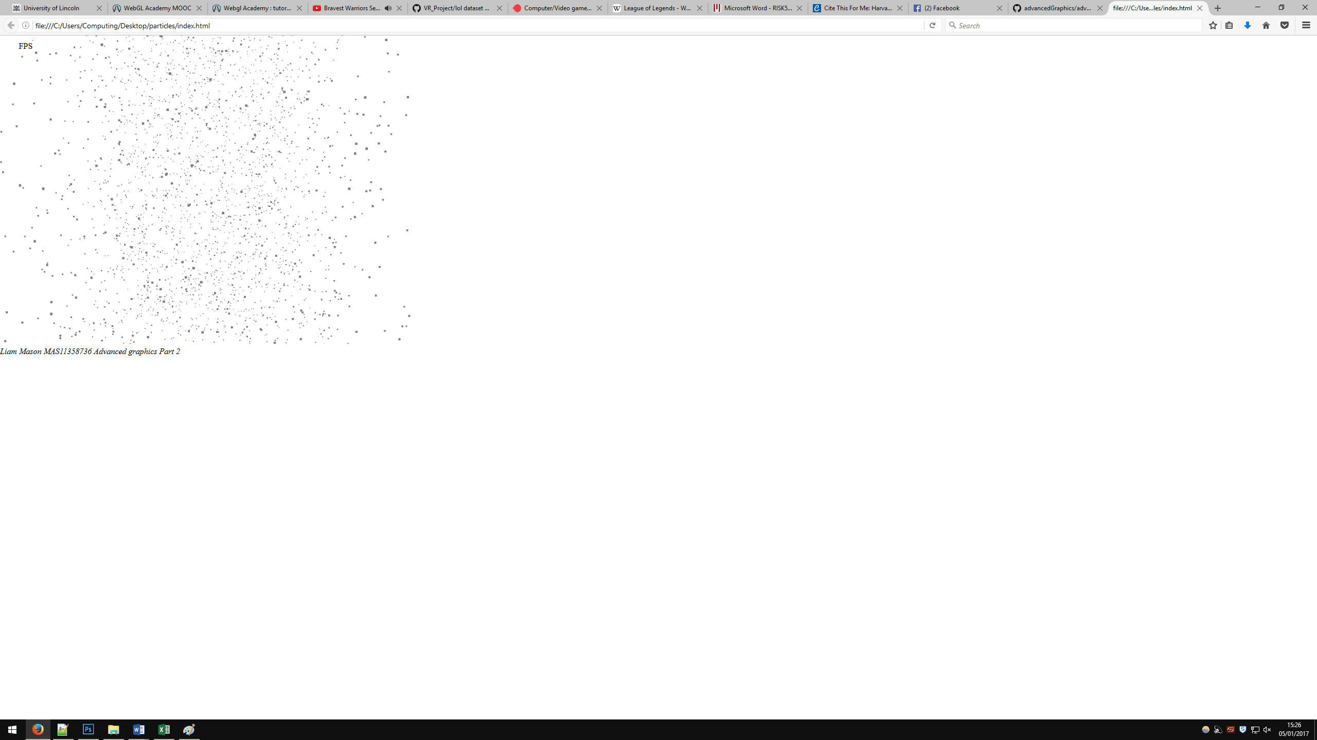

Particles effected by gravity. This screen shot shows 5000. Continuous flow when the particles reach a certain level on the Y axis they respawn at the top, just off camera, to create a continuous flow of particles.

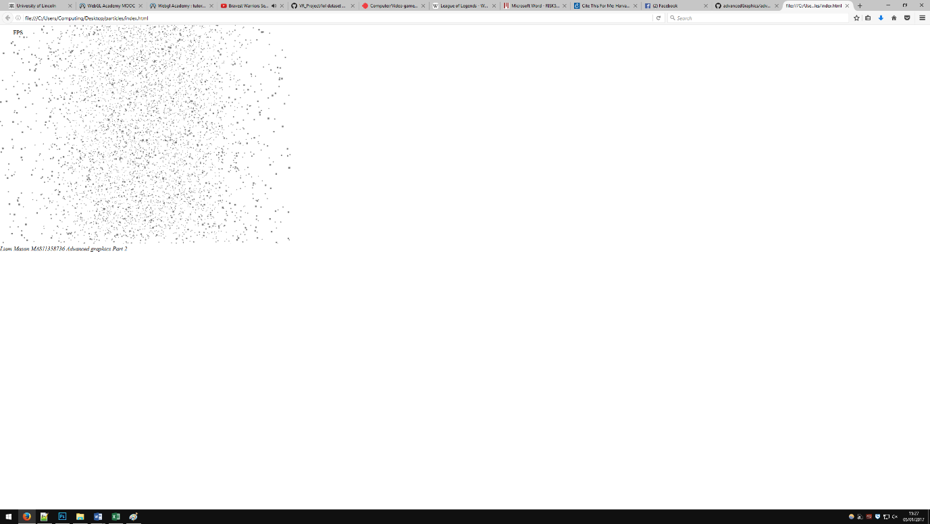

10000 particles effected by gravity, this how ever does make the FPS quite choppy so the submitted version contains 5000.

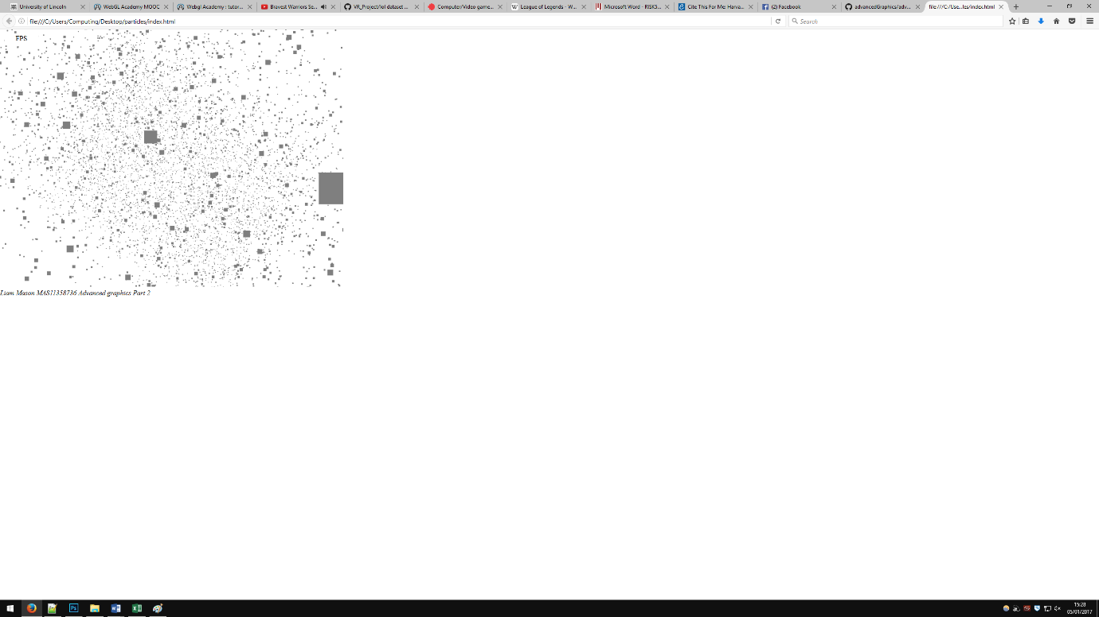

Bill boarded particles.

### Models

Textured Model. JSON

## 

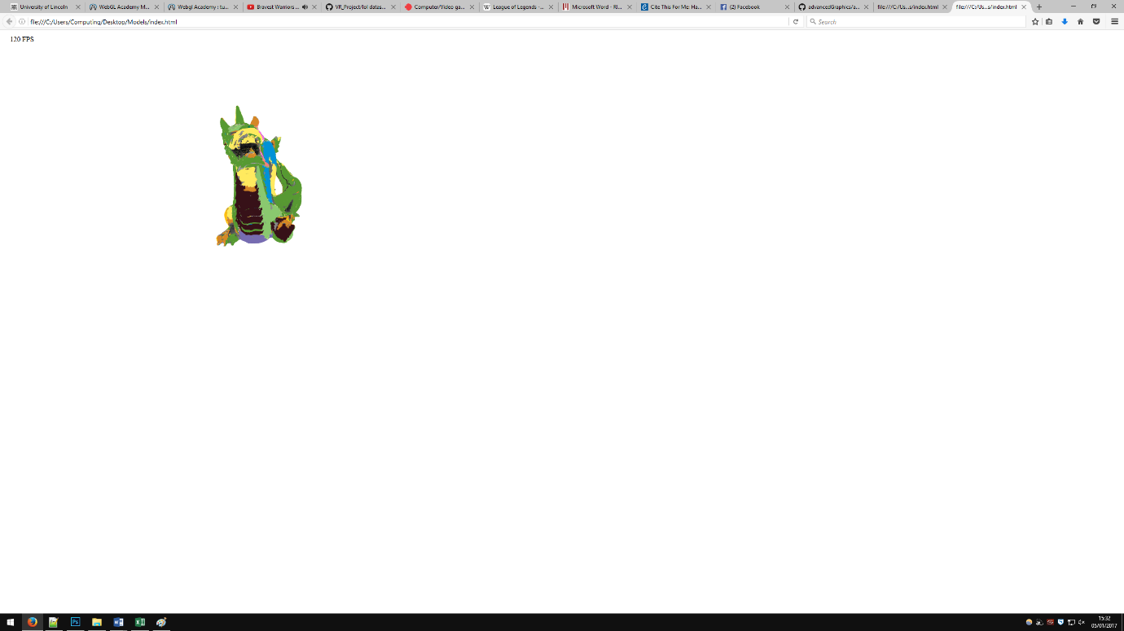

Different perspective of the Model.

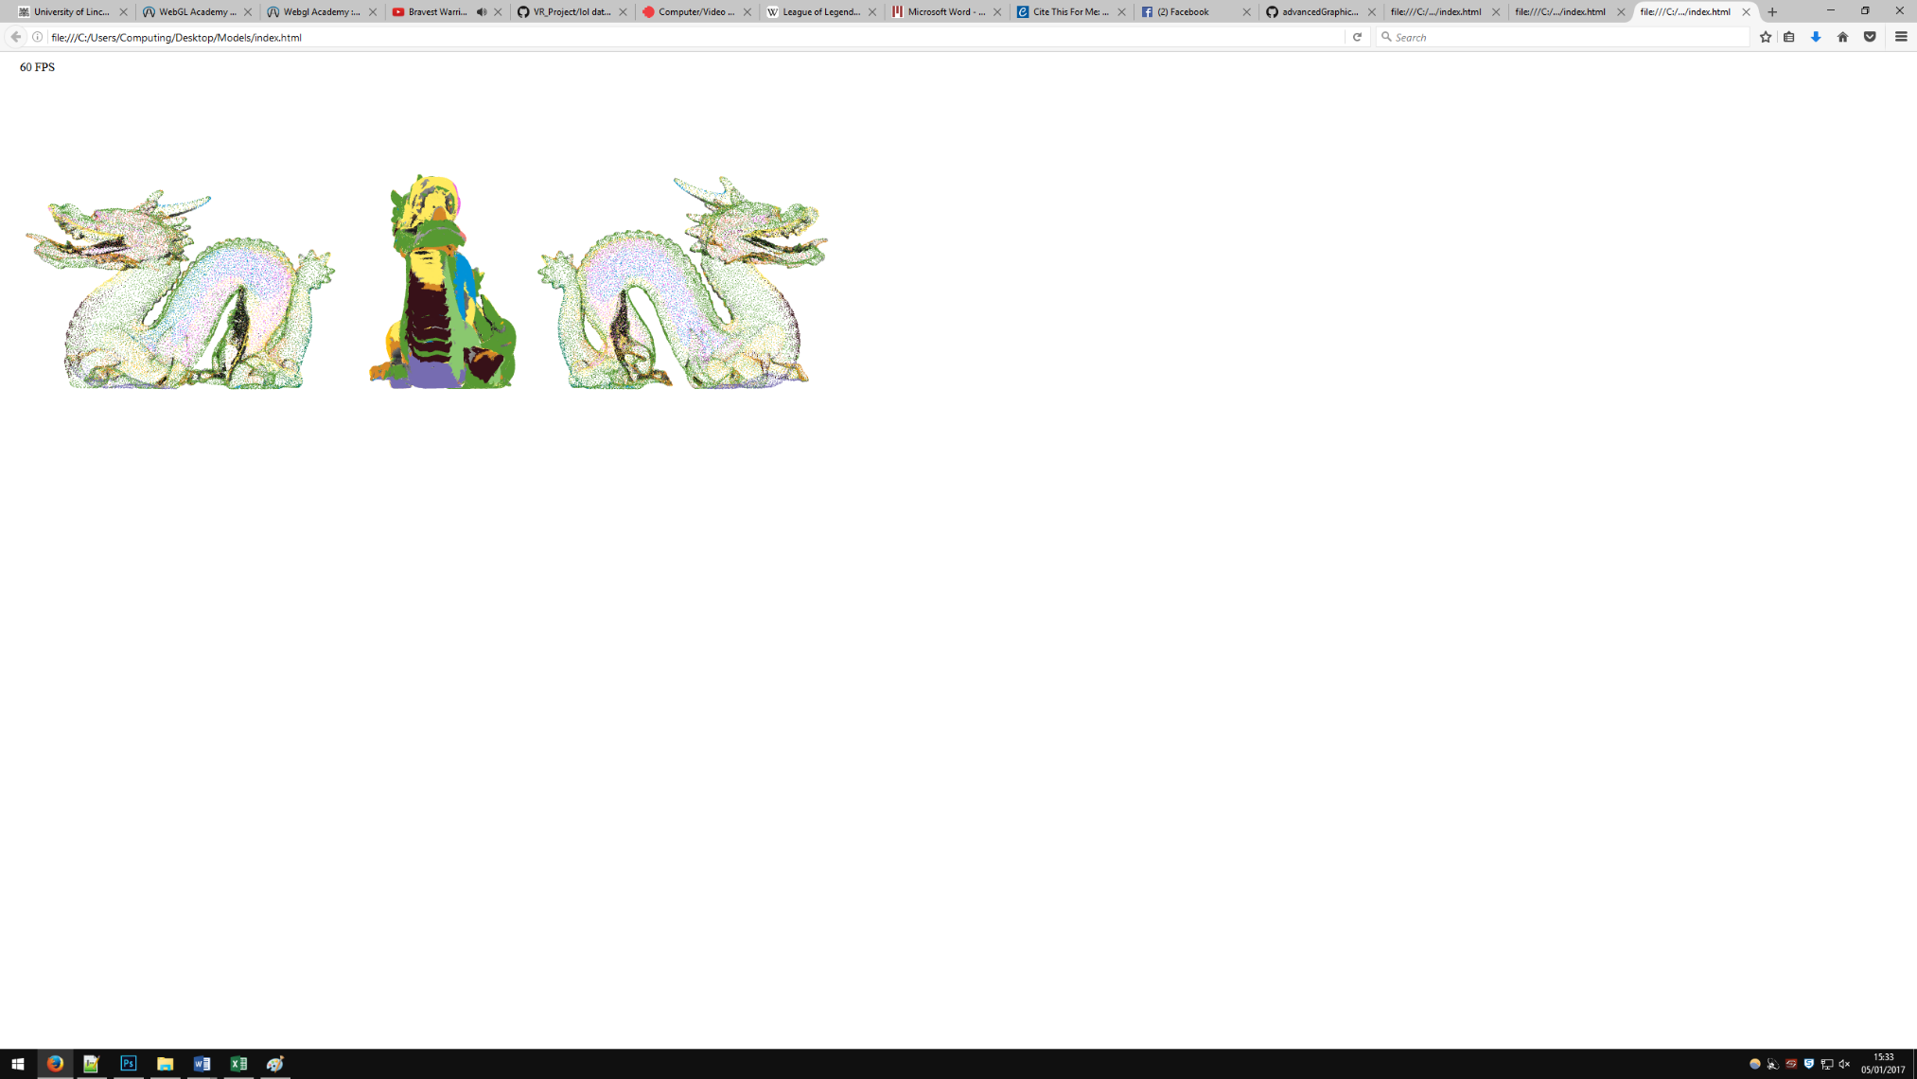

Multiple Models and Wireframes.

### FPS Counter

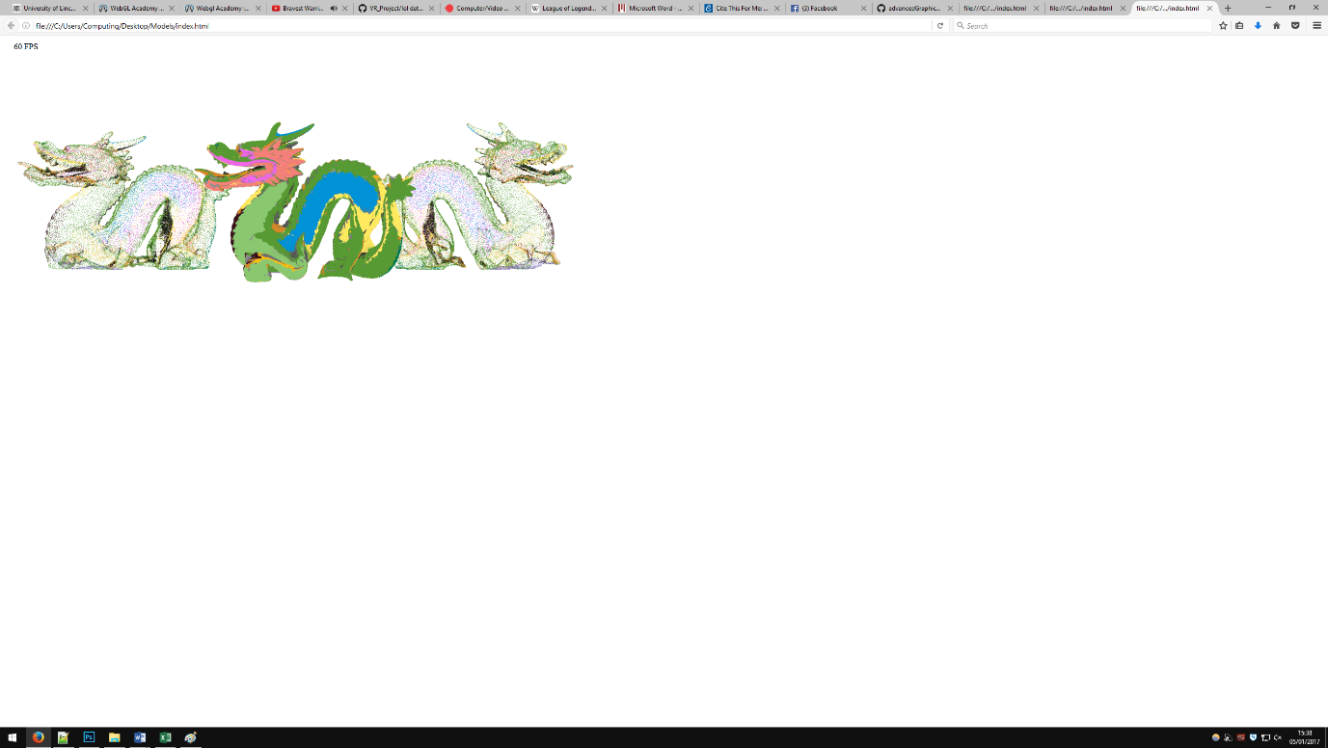

FPS counter for debugging purposes. With a single model in FPS counter showed 120 fps however with the submitted version it reached 60 FPS consistently.

## Reflection of development